Internship Report – Day 5

Objective
To practice 3D modeling in Autodesk Fusion (Education License) by designing a cup with a handle, applying sketching, extrusion, hollowing, and text engraving techniques.

Tools Used
- Autodesk Fusion 360 (Education License) – for CAD modeling
- GitHub – for saving and versioning design files

Steps & Evidence

Step 1: Starting the Design
- Opened Fusion and created a new project file.
- Set units to millimeters for precise modeling.
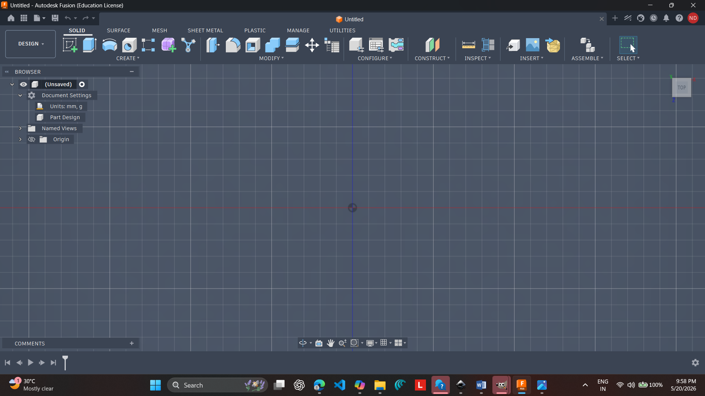

Step 2: Sketching the Cup Base
- Drew a circle on the XY plane to represent the cup’s bottom.
- Defined dimensions for diameter and wall thickness.
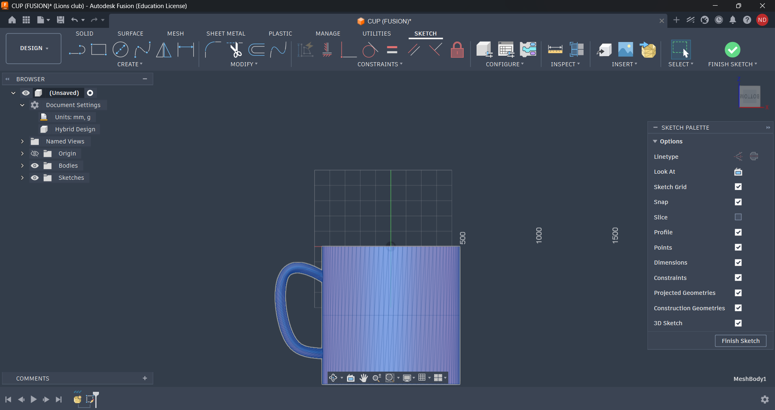

Step 3: Extruding the Cup Body
- Used the Extrude tool to create a cylindrical body.
- Applied Shell tool to hollow the cylinder, forming the cup interior.
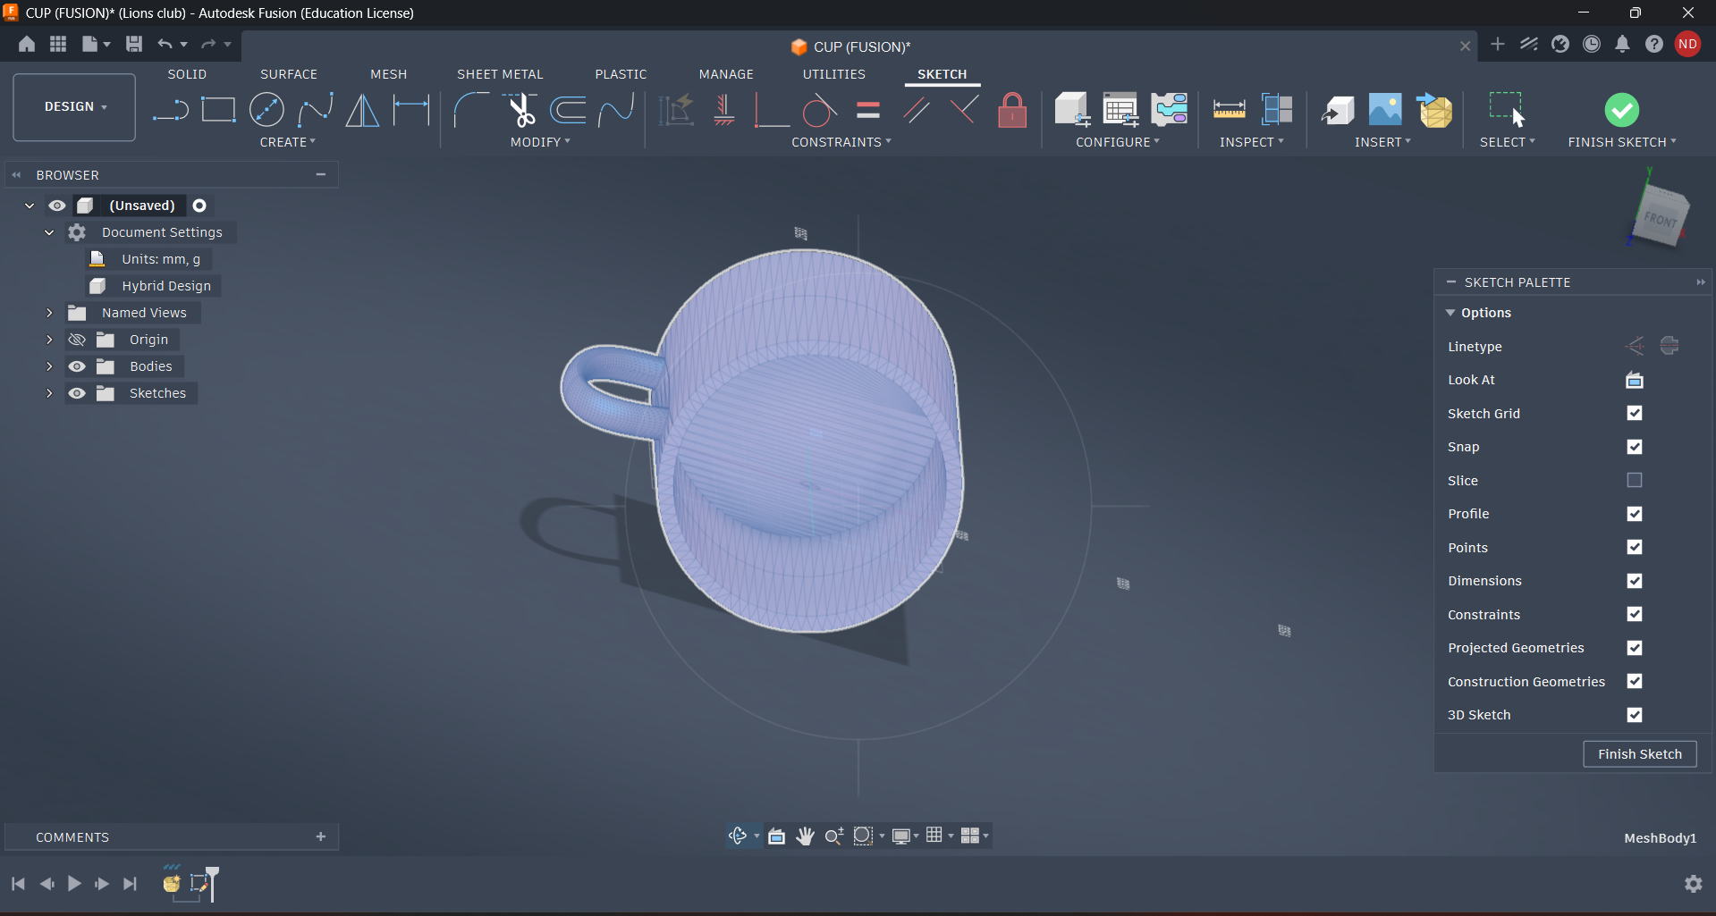

Step 4: Adding the Handle
- Used Sweep tool to generate a solid handle attached to the cup body.
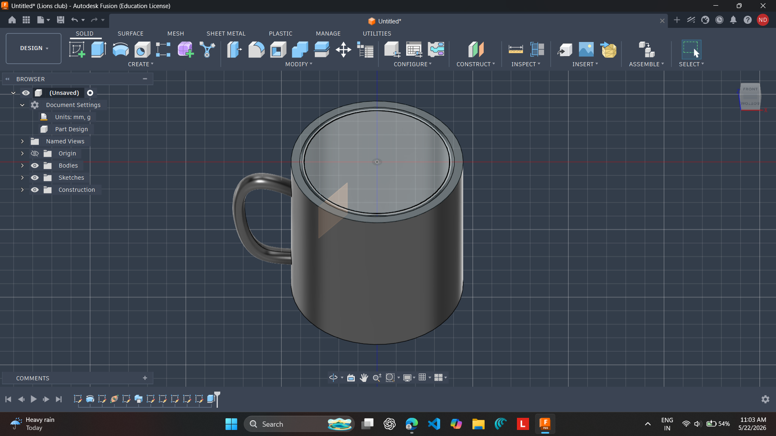
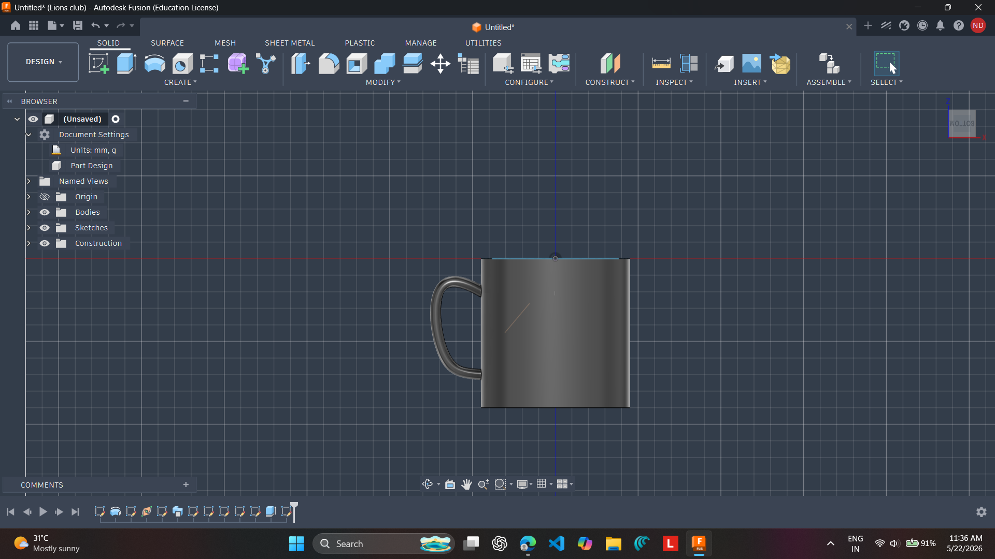

Step 6: Refining & Saving
- Smoothed edges with Fillet tool for realistic finish.
- Saved the design as Fusion file (.f3d) and exported renders.
- Pushed updated files to GitHub repository for documentation.

Step 7: Documentation & GitHub Push
- After finishing the cup modeling project in Fusion, I created a documentation file in VS Code.
- The documentation included:
  - Project overview (cup modeling objective)
  - Step-by-step workflow (sketch, extrusion, shell, handle, text engraving)
  - Screenshots of the Fusion workspace
  - Reflections and outcomes
- Saved the documentation as a Markdown file (.md) for easy readability.
- Used Git commands to stage and commit the documentation

Outcome
- Completed the cup modeling project with engraved text.
- Documented the entire workflow in VS Code for clarity and reproducibility.
- Integrated the project into GitHub, ensuring version control and collaboration readiness.

Reflection
Step 7 reinforced the importance of documentation and version control. By writing a clear report in VS Code and pushing it to GitHub, I ensured that my work is not only technically sound but also well-organized and shareable. This practice mirrors professional engineering workflows where design, documentation, and collaboration go hand-in-hand.

Conclusion – Day 5
Day 5 was a blend of technical design and professional documentation. I successfully modeled a personalized cup with a handle in Fusion, applying sketching, extrusion, shelling, sweeping, and text engraving tools. This exercise strengthened my CAD skills and gave me confidence in creating functional 3D models.
Beyond design, I emphasized the importance of documentation and version control. By writing a clear report in VS Code and pushing both the design files and documentation to GitHub, I ensured my work was organized, reproducible, and shareable. This workflow mirrors real engineering practice, where design, documentation, and collaboration are inseparable.
Day 5 reinforced that technical creativity must be paired with systematic documentation and collaboration tools. This balance prepares me for larger projects and team-based work in the future.

